IMPLEMENT K-MEANS CLUSTERING

AIM
To perform K-Means Clustering on a student dataset using Hours_Studied and Marks as features, group the students into three clusters, and visualize the clusters along with their centroids.

ALGORITHM
- Import the required libraries: Pandas, Matplotlib, and KMeans from Scikit-learn.
- Load the dataset from the CSV file data.csv.
- Select the features Hours_Studied and Marks for clustering.
- Create a K-Means clustering model with n_clusters=3 and random_state=42.
- Fit the model to the selected features using fit().
- Obtain the cluster labels using kmeans.labels_.
- Add the cluster labels as a new column named Cluster in the dataset.
- Display the clustered dataset.
- Plot the data points using a scatter plot, with colors representing different clusters.
- Plot the cluster centroids using an X marker.
- Add axis labels, a title, and a legend.
- Display the final clustering graph using plt.show().
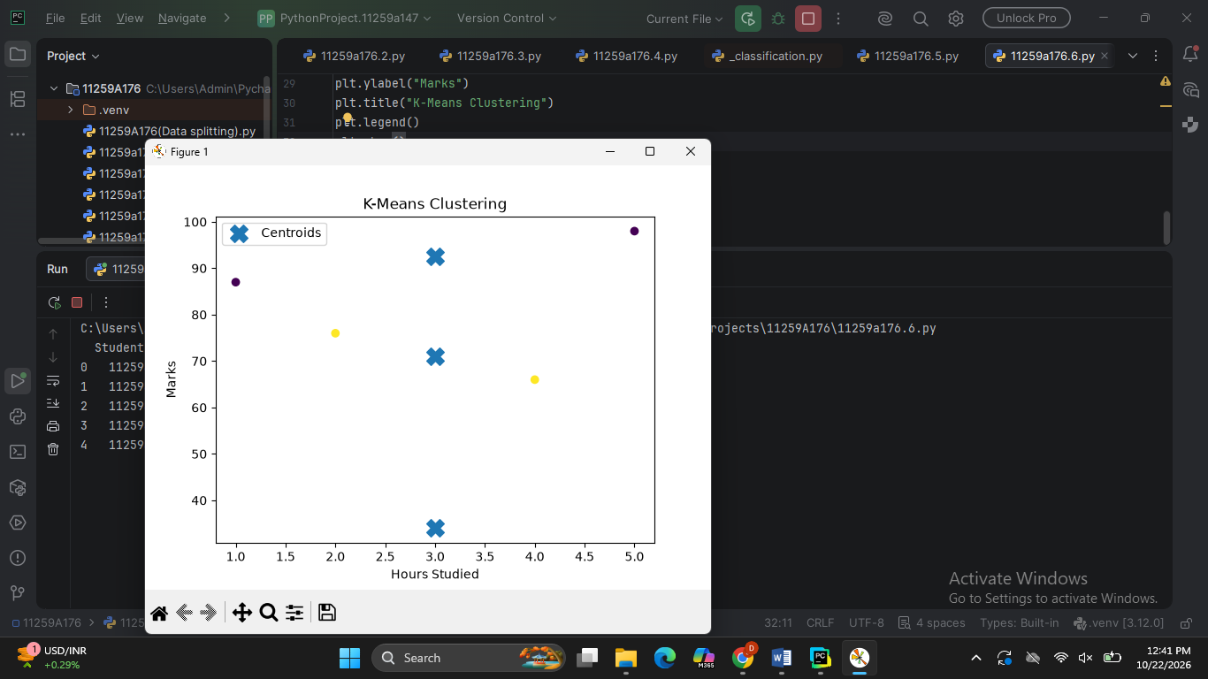

RESULT
K-Means Clustering was successfully applied to the student dataset using Hours_Studied and Marks. The students were grouped into three clusters, and the cluster labels were added to the dataset. A scatter plot displaying the clusters and their centroids was generated successfully.

